ARP Poisoning

Demonstrates how ARP Poisoning can be used on any network to redirect clients without their knowledge. The diagram below illustrates how it works.

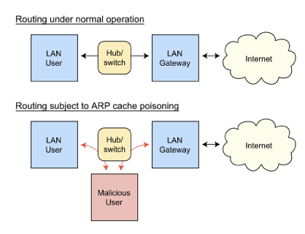

# Requirements

* Windows 7 VM (Modern.ie)
* Cain & Abel (http://www.oxid.it/cain.html)

# Server Setup

Try to disable your antivirus and firewall, it functions better.  
Go to Configure----> Sniffer and select your LAN Connection.

|  |
| --- |
| [ain%2526abel+hacking+arp](http://1.bp.blogspot.com/-GjAPa0mHaB4/TvNMNMxWhZI/AAAAAAAAAmg/RfciUBNB_KE/s1600/cain%2526abel+hacking+arp.png) |
| Click to Zoom |

Now Go to *Sniffer--> Click Hosts* (bottom Left)

[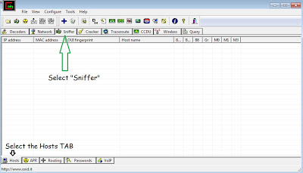](http://4.bp.blogspot.com/-iSCESANXBBw/TvNNEuuUXaI/AAAAAAAAAms/NRpY1S1nLDQ/s1600/cain%2526abel+hacking+arp2.png)

 Proceed as shown below. Scan for hosts by pressing the "+" Button

[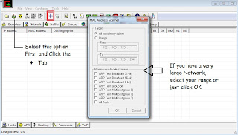](http://2.bp.blogspot.com/-GCjUosVBds4/TvNNQfkt3NI/AAAAAAAAAm4/bJf0TZ3AoNE/s1600/cain%2526abel+hacking+arp3.png)

 You should know your network gateway ( The Default Gateway ).  
Now we have all the LAN victims loaded, click on the APR tab located at the bottom left. Follow as below

[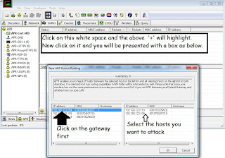](http://1.bp.blogspot.com/-56G_KLjNOrE/TvNObuiI3vI/AAAAAAAAAnQ/Xd0YuFASOLo/s1600/cain%2526abel+hacking+arp4.png)

[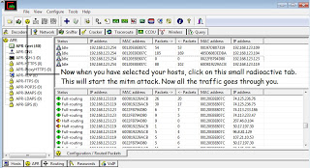](http://2.bp.blogspot.com/-PnoKsR3abQE/TvNOpUm_D3I/AAAAAAAAAnc/mi-lFPt_-OA/s1600/cain%2526abel+hacking+arp5.png)

Now come back to the APR tab. Click on APR-DNS

[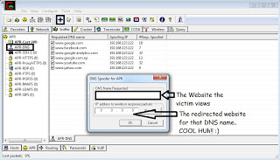](http://4.bp.blogspot.com/-gSvIBlCV1Dg/TvNO4TNhQqI/AAAAAAAAAno/NBVLTo-7YxQ/s1600/cain%2526abel+hacking+arp6.png)

Now you make facebook.com redirect to your website and yay!! play a jolly trick on your friend!

# References

http://www.hacktohell.org/2011/12/hacking-computer-in-lan-by-arp.html